# Integrating Stride Analytics Library in Xcode

To integrate the StrideAnalytics library (libStrideAnalytics.a) into an iOS project,

1. Open the project, and create a new group.

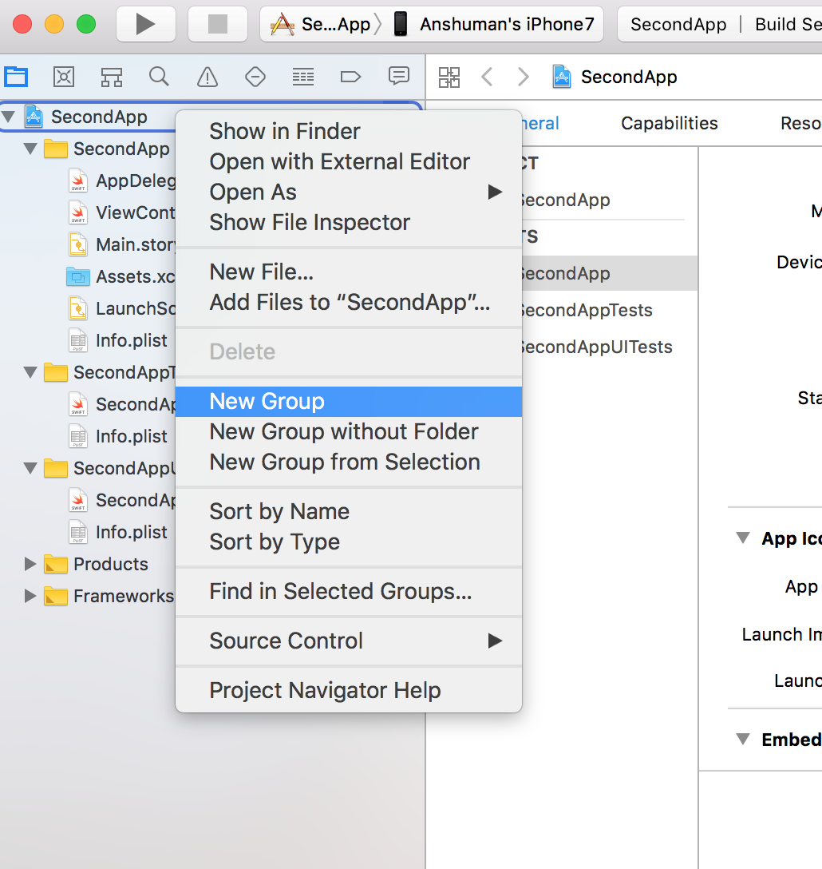

2. Name the group, and then right-click and select “Add files to group”.

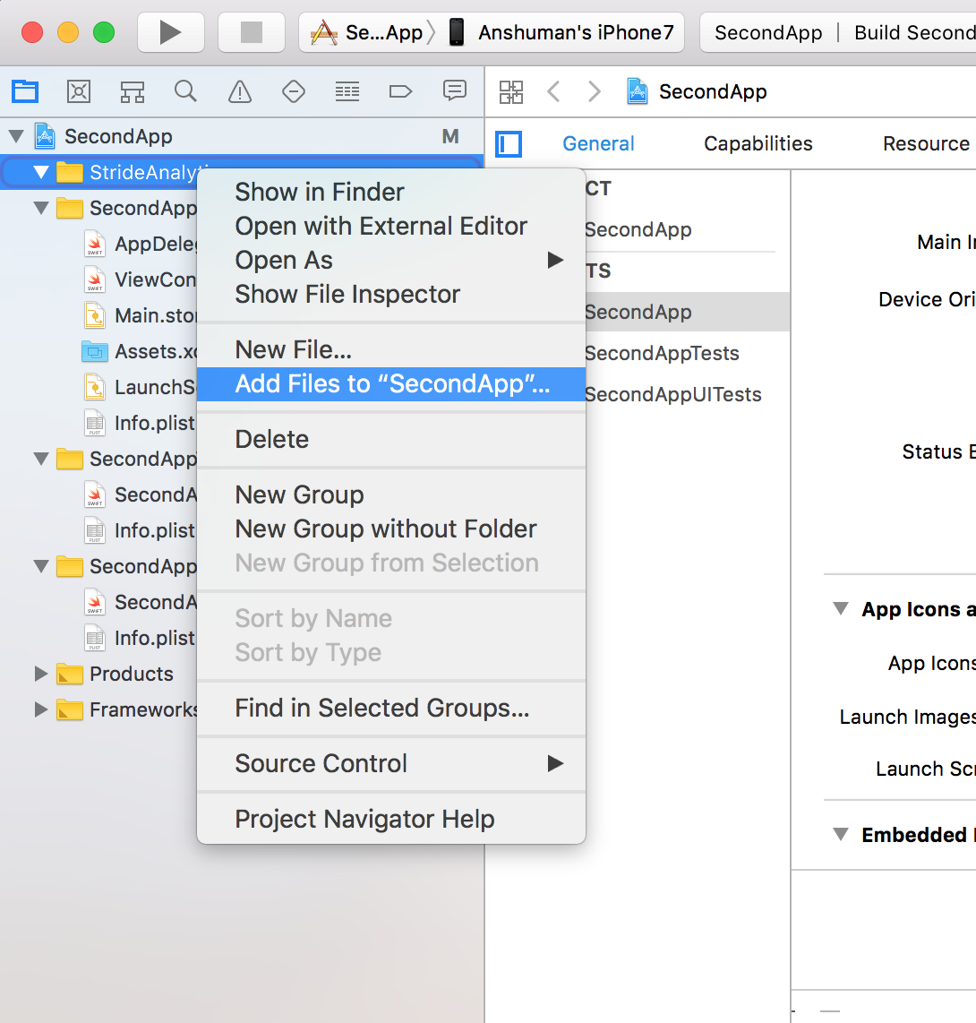

3. Browse to the AnalyticsLib.h and libStrideAnalytics.a files, select them both, and click “Add”.

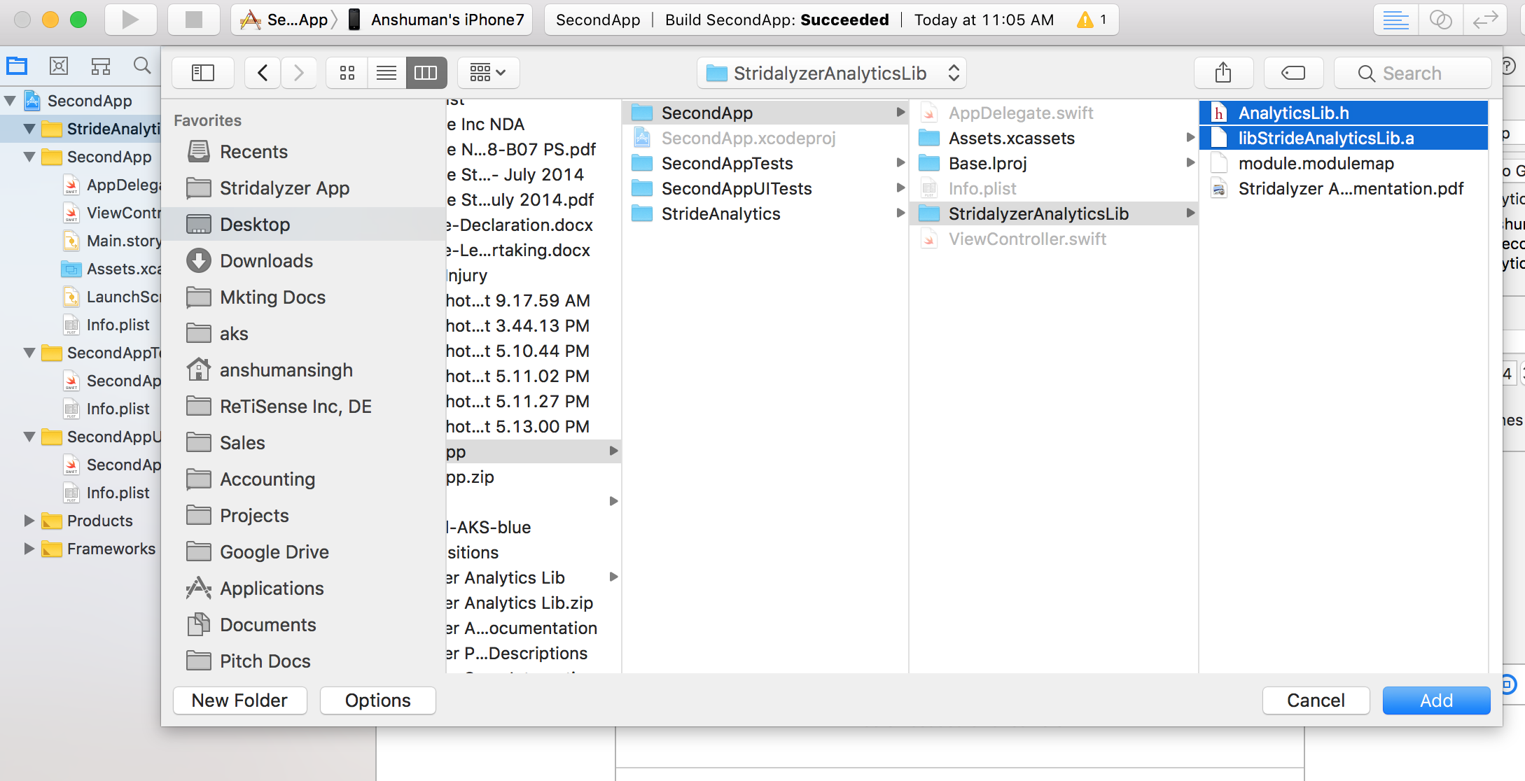

4. Verify that the library was added by selecting your primary build target, and checking the “Linked Framework and libraries” for libStrideAnalytics.a.

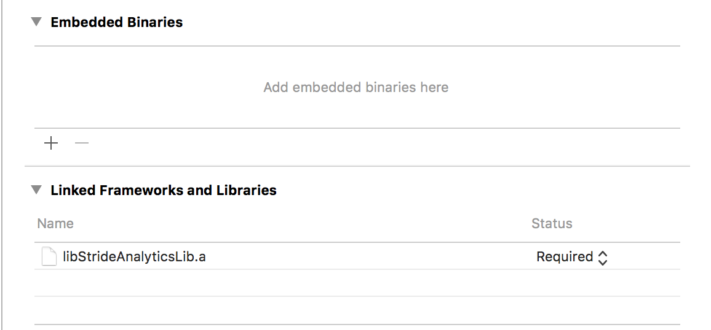

5. Library is integrated in the project. Now you can use the functions in AnalyticsLib.h in global scope throughout the app.